Fake News Detection And Verification Tool

1. Introduction
With the rapid expansion of the internet, social media platforms, and online news portals, the consumption of digital news has increased significantly. Along with this growth, the problem of fake news has also escalated. Fake news refers to “misleading, false, or fabricated information presented as legitimate news with the intention to deceive readers.” Such misinformation can influence public opinion, create panic, harm reputations, and even impact political and social stability.
Traditional methods of verifying news involve manual fact-checking by experts, which is time-consuming, expensive, and not scalable for the vast amount of content generated daily. Therefore, automated solutions are required to detect fake news quickly and efficiently.
The Fake News Detection System proposed in this project addresses this issue by using machine learning techniques integrated into a Flask-based web application. The system allows users to submit news text through a web interface and instantly receive a classification result indicating whether the news is Fake or Real. Additionally, the system maintains a history of analyses and provides an admin panel for monitoring user activity and analysis data.

2. Problem Statement
In today’s digital era, users consume news from various online sources without verifying its authenticity. The lack of an easy-to-use verification system results in the rapid spread of misinformation. Existing systems are either complex or not user-friendly.
Problem:
- Difficulty in identifying fake news manually
- Rapid spread of misinformation
- Lack of centralized and user-friendly fake news detection platforms

3. Objectives of the Project
The main objectives of this project are:
- To design a web-based fake news detection system
- To classify news content as fake or real using machine learning
- To provide a secure user authentication system
- To store and display analysis history
- To provide an admin panel for monitoring users and analyses

4. Scope of the Project
- The system focuses on text-based news analysis
- It can be accessed via a web browser
- Suitable for students, researchers, and general users
- Can be extended to support multiple languages and media types

5. System Overview
The Fake News Detection System is implemented as a Flask web application. Users interact with the system through HTML-based frontend pages. The backend processes user input, performs fake news classification, and stores the results. An admin module is included for system monitoring.

6. Technologies Used
6.1 Software Requirements
- Programming Language: Python
- Web Framework: Flask
- Frontend: HTML, CSS
- Version Control: GitHub

6.2 Libraries and Tools
- Flask – Web application framework
- Machine Learning libraries (used for fake news classification)
- Logging utilities for system monitoring

7. System Architecture
The Fake News Detection System follows a client–server architecture where the client interacts with the server through a web browser. The architecture is designed to separate concerns such as user interaction, application logic, machine learning processing, and data storage.

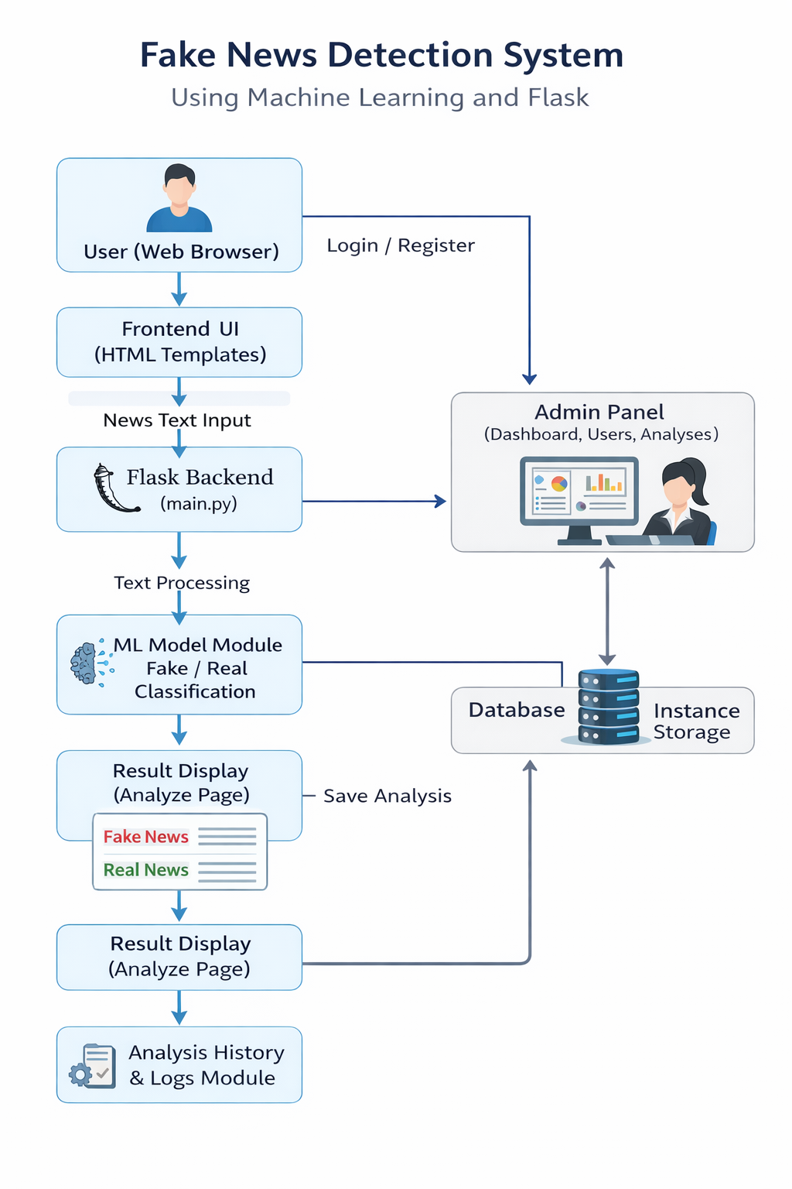
Architecture Flow:
- The user accesses the system using a web browser.
- The frontend interface, developed using HTML templates, collects user input.
- The Flask backend receives HTTP requests and handles routing and business logic.
- The news text is processed and passed to the machine learning model.
- The model predicts whether the news is fake or real.
- The result is returned to the frontend and displayed to the user.
- The analysis result is stored in the system database or instance storage.
- Admin users can view user details, analyses, and system logs through the admin panel.
This architecture ensures modularity, scalability, and ease of maintenance.

8. Block Diagram Explanation
The block diagram consists of the following components:
- User (Web Browser): Interacts with the system
- Frontend UI: HTML templates for user interaction
- Flask Backend: Handles application logic
- ML Model Module: Performs fake/real classification
- Database / Instance Storage: Stores analysis results
- Logs Module: Maintains logs
- Admin Panel: Manages users and analyses

9. Module Description

The system is divided into multiple modules, each responsible for a specific functionality. This modular approach improves maintainability and clarity of the application.
9.1 User Module
The User Module manages all user-related operations. It provides functionalities such as:
- User registration with basic details
- Secure login authentication
- User profile viewing and management
This module ensures that only authenticated users can access the news analysis features.
9.2 News Analysis Module
The News Analysis Module is the core component of the system. Its responsibilities include:
- Accepting news text input from the user
- Preprocessing the text
- Passing the processed text to the machine learning model
- Receiving classification results
- Displaying the output as Fake or Real
9.3 Analysis History Module
This module stores the results of all previous analyses performed by users. It allows users to:
- View their past analysis results
- Track previously submitted news content
Maintaining history helps in transparency and reference.
9.4 Admin Module
The Admin Module provides administrative control over the system. It includes:
- Admin dashboard for system overview
- Viewing registered users
- Monitoring news analyses performed by users
This module helps in managing and supervising the application effectively.
9.5 Logging Module
The Logging Module records system activities and events. These logs are useful for:
- Debugging application errors
- Monitoring system behavior
- Improving system reliability

10. Folder Structure Explanation
The project follows a structured folder organization:
- main.py: Core Flask application
- templates/: HTML files for frontend
- admin/: Admin-related templates
- instance/: Application runtime storage
- logs/: System log files
- README.md: Project description

11. Working of the System
- User registers or logs in
- User enters news text
- Flask backend receives input
- Text is processed and sent to ML model
- Model predicts fake or real
- Result is displayed
- Analysis is saved in history
- Admin can view records

12. Sample Output
- User enters news text
- System analyzes content
- Output displayed as:
  - Fake News
  - Real News

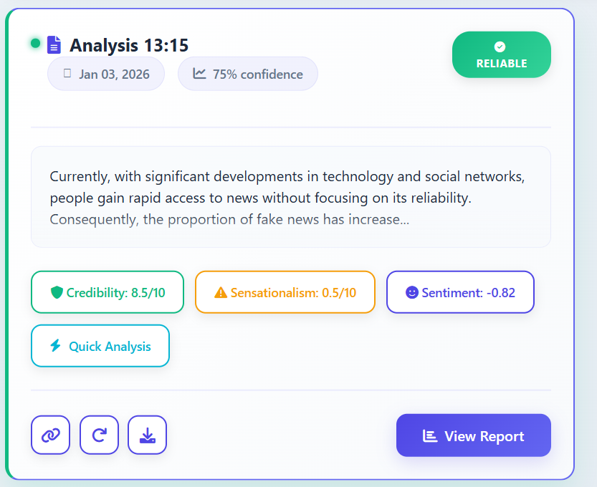

13. Advantages
- User-friendly web interface
- Automated fake news detection
- Secure authentication system
- Admin monitoring facility
- Scalable and extensible

14. Limitations
- Works only with text-based news
- Accuracy depends on training data
- Does not analyze images or videos

15. Future Enhancements
- Integration of deep learning models
- Multi-language support
- Image and video fake news detection
- Mobile application development

16. Conclusion
The Fake News Detection System successfully demonstrates the use of machine learning integrated with a Flask web application to detect fake news. The project provides an efficient, user-friendly, and scalable solution to combat misinformation. With further enhancements, the system can be expanded into a comprehensive news verification platform.

17. GitHub Repository
Project Link:
https://github.com/rajashrikal/Fake_news_detector_pythonproject

